Бреусов Денис 22919/21
Дешифратор
A2 | A1 | A0 | E | D7 | D6 | D5 | D4 | D3 | D2 | D1 | D0
0 | 0 | 0 | 0 | X | X | X | X | X | X | X | X
0 | 0 | 0 | 1 | 0 | 0 | 0 | 0 | 0 | 0 | 0 | 1
0 | 0 | 1 | 0 | X | X | X | X | X | X | X | X
0 | 0 | 1 | 1 | 0 | 0 | 0 | 0 | 0 | 0 | 1 | 0
0 | 1 | 0 | 0 | X | X | X | X | X | X | X | X
0 | 1 | 0 | 1 | 0 | 0 | 0 | 0 | 0 | 1 | 0 | 0
0 | 1 | 1 | 0 | X | X | X | X | X | X | X | X
0 | 1 | 1 | 1 | 0 | 0 | 0 | 0 | 1 | 0 | 0 | 0
1 | 0 | 0 | 0 | X | X | X | X | X | X | X | X
1 | 0 | 0 | 1 | 0 | 0 | 0 | 1 | 0 | 0 | 0 | 0
1 | 0 | 1 | 0 | X | X | X | X | X | X | X | X
1 | 0 | 1 | 1 | 0 | 0 | 1 | 0 | 0 | 0 | 0 | 0
1 | 1 | 0 | 0 | X | X | X | X | X | X | X | X
1 | 1 | 0 | 1 | 0 | 1 | 0 | 0 | 0 | 0 | 0 | 0
1 | 1 | 1 | 0 | X | X | X | X | X | X | X | X
1 | 1 | 1 | 1 | 1 | 0 | 0 | 0 | 0 | 0 | 0 | 0
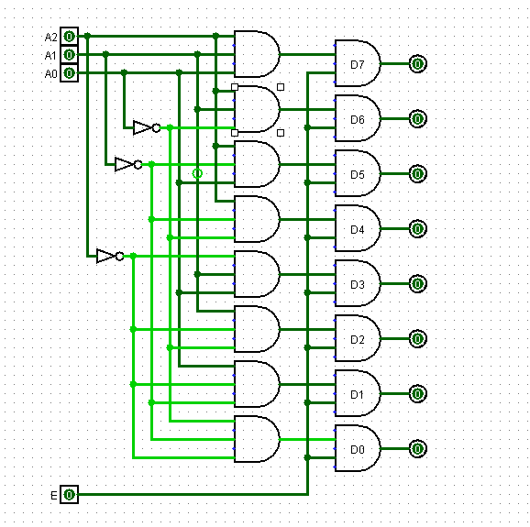

E | A2 | A1 | A0 | D7 | D6 | D5 | D4 | D3 | D2 | D1 | D0
0 | Люб. | Люб. | Люб. | Люб. | Люб. | Люб. | Люб. | Люб. | Люб. | Люб. | Люб.
1 | 0 | 0 | 0 | 0 | 0 | 0 | 0 | 0 | 0 | 0 | 0
1 | 0 | 0 | 1 | 0 | 0 | 0 | 0 | 0 | 0 | 0 | 0
1 | 0 | 1 | 0 | 0 | 0 | 0 | 0 | 0 | 0 | 0 | 0
1 | 0 | 1 | 1 | 0 | 0 | 0 | 0 | 0 | 0 | 0 | 0
1 | 1 | 0 | 0 | 1 | 0 | 0 | 0 | 0 | 0 | 0 | 0
1 | 1 | 0 | 1 | 0 | 0 | 0 | 0 | 1 | 1 | 1 | 0
1 | 1 | 1 | 0 | 0 | 0 | 1 | 1 | 0 | 0 | 0 | 0
1 | 1 | 1 | 1 | 0 | 0 | 0 | 0 | 0 | 0 | 0 | 1
Задание 2
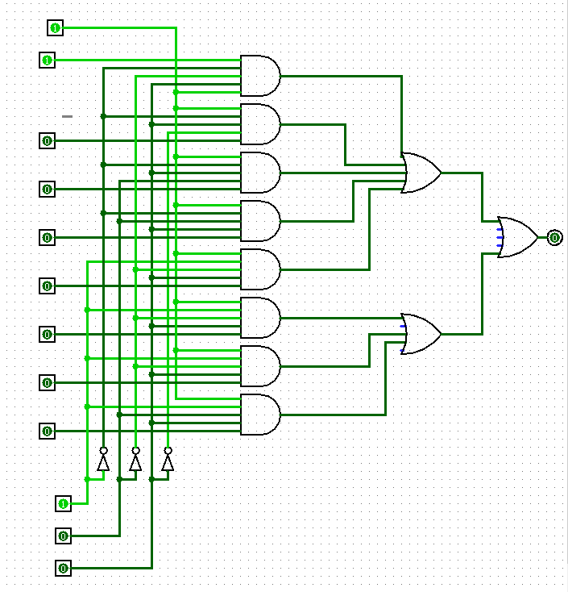

Задание 3
A | B | P | S
0 | 0 | 0 | 0
0 | 1 | 0 | 1
1 | 0 | 0 | 1
1 | 1 | 1 | 0
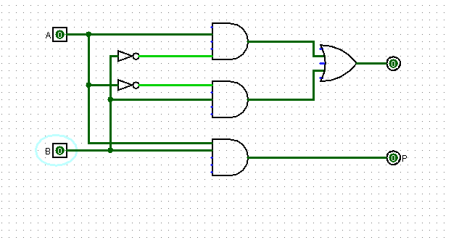
полусумматор

Задание 4:
Входы |  |  | Выходы
A_{i} | B_{i} | P_{i-1} | S_{i} | P_{i+1}
0 | 0 | 0 | 0 | 0
0 | 0 | 1 | 1 | 0
0 | 1 | 0 | 1 | 0
0 | 1 | 1 | 0 | 1
1 | 0 | 0 | 1 | 0
1 | 0 | 1 | 0 | 1
1 | 1 | 0 | 0 | 1
1 | 1 | 1 | 1 | 1
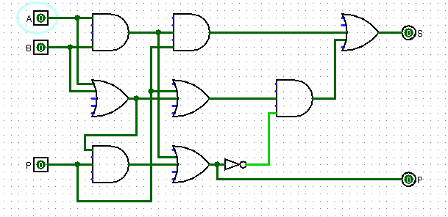
сумматор

